**ASSIGNMENT 4 – COURSE LIST APPLICATION WITH REDUX**

**Steps :**

1. Create app courselistredux and install required packages

ubuntu@ip-172-31-25-178:~$ cd courselistredux

ubuntu@ip-172-31-25-178:~/courselistredux$ npm i redux react-redux redux-promise react-router-dom react-slick

ubuntu@ip-172-31-25-178:~/courselistredux$ sudo npm install json-server

ubuntu@ip-172-31-25-178:~/courselistredux/src/components$ json-server --watch db.json --port 7000

ubuntu@ip-172-31-25-178:~/courselistredux/ $ npm start

**Code :**

https://github.com/hemapunniakotti/ReactProjects/Assignement4_CourselistRedux

**Output :**

1. Courselist app has been implemented using Redux. The data comes from static api hosted through the index file under action folder [Figure 1]

Figure

1. Below page captures user enquiries

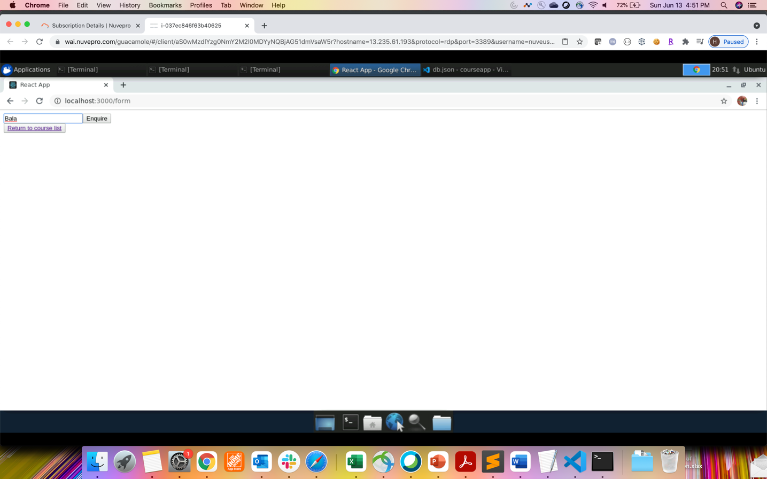

1. The enquiries is listed from the db.json which gets updated after user makes an enquiry.

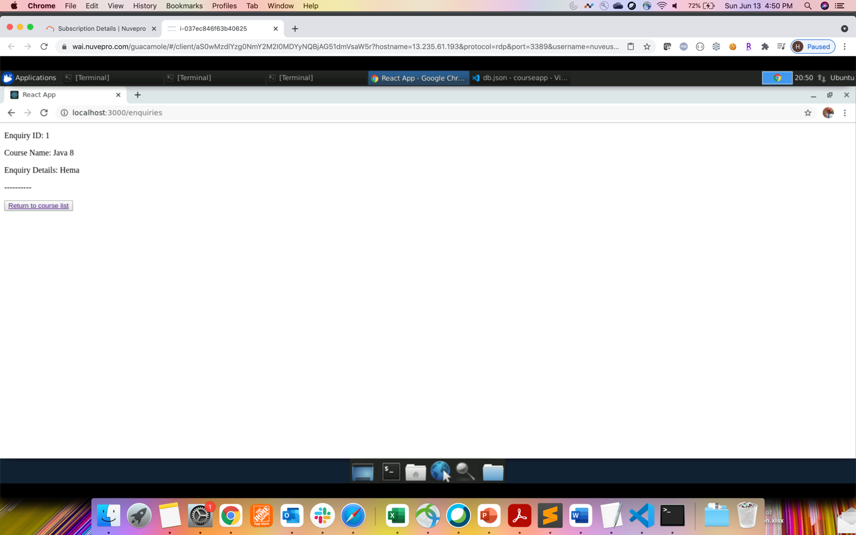

1. After user makes second entry –

1. Data gets updated in the db.json file –

